**NOTRE DAME UNIVERSITY BANGLADESH**



Data Structure Report

Task- 07

Submitted to: Humayara Binte Rashid

Submitted by: Shazidul Alam

Subject: Data Structure

Student ID: 0692220005101009

Batch: CSE-19

**1(a).Write a code to find the factorial of N using a)recursion.  
Sample Input: 5  
Output: 120**

Soution:

#include <stdio.h>

int factorial(int n) {

if (n == 0 || n == 1) {

return 1;

} else {

return n * factorial(n - 1); }

}

int main() { int n;

printf("Enter a number: ");

scanf("%d", &n);

if (n < 0) {

printf("Factorial is not defined for negative numbers.\n");

} else {

int result = factorial(n);

printf("Factorial of %d is %d\n", n, result); }

return 0;}

Output:

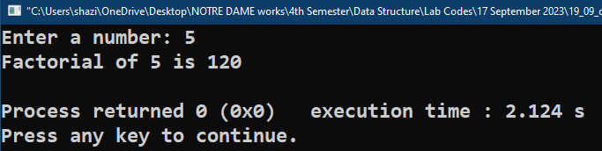

**1(b).Write a code to find the factorial of N using b)using for loop.  
Sample Input: 5  
Output: 120**

Solution:

#include <stdio.h>

int main() {

int N;

printf("Enter a number: ");

scanf("%d", &N);

if (N < 0) {

printf("Factorial is not defined for negative numbers.\n");

} else {

int result = 1;

for (int i = 1; i <= N; i++) {

result =result*i;

}

printf("Factorial of %d is %d\n", N, result);

}

return 0;}

Output:

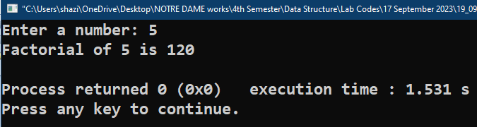

**2. Write a code to find the Nth number of fibonacci series with recursion.  
Sample input: 6  
Output: 5  
Bonus: print till Nth number.  
Series Output: 0 1 1 2 3 5**

Solution:

#include <stdio.h>

int fibonacci(int n) {

if (n == 1) {

return 0;

}

else if (n==2){

return 1;

}

else {

return fibonacci(n - 1) + fibonacci(n - 2); }

}

int main() {

int N;

printf("Enter a positive integer N: ");

scanf("%d", &N);

if (N < 0) {

printf("Invalid input. N should be a positive integer.\n"); }

else {

int result = fibonacci(N);

printf("Fibonacci of %d is %d\n", N, result);

}

return 0;}

Output:

